Naive Bayes
- Supervised Learning Algorithm
- Classification and Regression.
- Probability Theory - Conditional Probability
Key terms:
- Naive - Every feature is independent to each other.
- bayes - Bayes Theorem - Conditional Probability
Example:
- Email Classification
- Spam, Not Spam - Dependent Feature
- Text / Email - Independent Feature
- CountVectorizer - Word frequency counts -
  - Vocabulary = Num. of unique words in the entire dataset.
  - Vocab counts
  - Lib in sklearn : https://scikit-learn.org/1.5/modules/generated/sklearn.feature_extraction.text.CountVectorizer.html
Sentence1 = I hope you are doing well - Not Spam
Sentence2 = I hope you are good. - Not Spam

Sentence1 = ? Probability score = 0 and 1
Binary Classification = Spam & Ham
Unseen sentence / sample = Probability Score = 0.9 (Spam), 1 - 0.9 = 0.1 (Not Spam)

Vocabulary: unique words from dataset
 | I | hope | you | are | doing | well | good
I hope you are doing well. | 1 | 1 | 1 | 1 | 1 | 1 | 0
I hope you are good. | 1 | 1 | 1 | 1 | 0 | 0 | 1
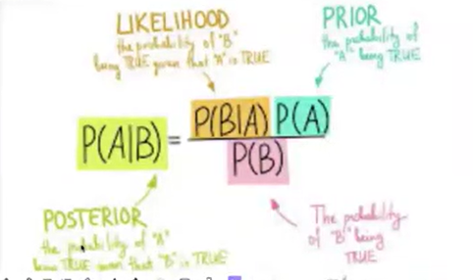
Theorem:
P(A|B)=P(B|A) * P(A) / P(B)
Terminology:
- Posterior → P(A|B)
  - The probability of A being TRUE given that B is TRUE.
- Likelihood → P(B|A)
  - The probability of B being TRUE given that A is TRUE.
- Prior → P(A)
  - The probability of A being TRUE.
- Evidence → P(B)
  - The probability of B being TRUE.
\
For numeric values/ continuous values:
- Gaussian naive bayes
- We cannot' freq table.
- Mean and Standard Deviation.
Numeric = Gaussian Naive Bayes:
- Real values.
Text = Multinomial Naive Bayes / Naive Bayes -
- Suitable for discrete values
- Word frequency counts

